Evaluating the direct, indirect and population-level effects of Long-lasting insecticidal nets (LLINs) across transmission intensities

Background
Malaria control has made substantial gains over the past two decades, largely due to the scale-up of long-lasting insecticidal nets (LLINs) through mass distribution campaigns. Between 2000 and 2015, LLINs was found to have contributed 68% of the 663 million clinical malaria cases averted in endemic Africa, where LLIN is the dominant vector control intervention [1,2]. As a result, LLINs are widely regarded as among the most cost-effective public health interventions against malaria [3]. Their effectiveness arises from two complementary mechanisms: physical prevention of mosquito bites and the insecticidal action that kills or deters mosquitoes. Individuals sleeping under intact, treated nets benefit from direct personal protection, while populations benefit from indirect protection through reduced mosquito density, survival, and proportion of infectious mosquitoes. This community-level protection, sometimes referred to as indirect or community effect in previous studies means that individuals who do not themselves use nets may nonetheless experience reduced malaria risk when net usage in the population is high [4–8]. This provides some level of protection for individuals who do not use nets in settings where universal usage of nets is not achieved.
Evidence for the community-level protection of LLINs has been demonstrated across multiple empirical [9–12] and modelling [13–15] studies, most notably from western Kenya, where reductions in malaria prevalence and child mortality were observed not only among net users but also among non-users living near households using nets [9]. Recognizing these indirect effects motivated a shift in malaria control policy from targeted net distribution toward universal coverage strategies [16]. By extending protection to all age groups, including adults who contribute to onward transmission, universal coverage aims to maximize both direct and population-level benefits [16]1a<. A growing body of work indicates that indirect effects are heterogeneous and sensitive to local transmission dynamics, intervention coverage, and vector ecology. Recent re-analyses of cluster-randomized trials of malaria interventions such as chemoprevention and/or indoor residual spraying have demonstrated substantial spillover effects on incidence and prevalence among non-recipients, but also highlighted that such effects vary with spatial scale, baseline transmission intensity, and intervention mix [17]. Systematic syntheses of these findings confirm that community effects contribute substantially to the overall impact of LLINs, particularly once coverage exceeds moderate levels [8].

Although these studies have shown that LLINs provide direct and community-level protection, important gaps remain in understanding how these benefits are distributed across users, non-users, and the overall population under different transmission intensities. Transmission intensity, often summarized by the entomological inoculation rate (EIR), is likely to be a critical determinant of community-level effects as it ranges from <1 to >1000 ib/person/year in the sub-Saharan African. This indicates a wide heterogeneity between countries [3]. For instance, at high transmission intensity, persistent exposure to infectious bites may constrain the degree to which reductions in mosquito survival translate into meaningful reductions in human infection prevalence, potentially leading to saturation of indirect effects even at high LLIN usage. [4,18]. Empirical studies are often context-specific and do not permit a clean decomposition of protection components, while existing modelling studies have rarely provided a unified comparison of direct, indirect, and overall LLIN protection across a structured EIR range. The magnitude and consistency of these effects remain heterogeneous across settings, and the extent to which increasing coverage yields additional benefits is not fully understood. Policy recommendations emphasize achieving high or universal LLIN coverage, often without explicitly considering how the additional benefits of increasing coverage vary across epidemiological contexts [19]. In resource-constrained settings, where funding limitations necessitate prioritization, it is critical to understand not only the total impact of LLINs but also how incremental increases in coverage translate into additional epidemiological benefit. In particular, it remains unclear whether increasing coverage beyond certain levels yields diminishing returns, and how such patterns differ across transmission intensities.
To our knowledge, the literature has been much stronger on documenting total direct and community effects than on asking where along the coverage gradient the next increase in coverage yields the greatest return or what coverage thresholds are required to achieve meaningful community-level protection. Moreover, the joint analysis of direct and indirect protection, incremental benefits, and policy-relevant thresholds within a unified framework remains limited. In this study, we use a mathematical modelling approach to evaluate the impact of LLIN coverage across a range of transmission intensities. Specifically, we aim to: (i) quantify the direct (user) and indirect (non-user) protection conferred by LLINs across coverage levels; (ii) characterize the marginal (incremental) benefit of increasing LLIN coverage; and (iii) identify coverage thresholds required to achieve meaningful reductions in malaria prevalence among non-users. By integrating these perspectives, we provide a comprehensive assessment of how LLIN coverage translates into epidemiological impact and derive policy-relevant insights for optimizing intervention strategies under constrained resources.

Methods

Simulation model
OpenMalaria is an individual-based model used to simulate the dynamics of malaria transmission and epidemiology, and the impact of interventions on health and economic outcomes. It is a stochastic open-source platform initially designed for modeling malaria vaccines [20,21]. The model simulates various aspects, including the dynamics of malaria parasitemia during infection, the life cycle of mosquitoes, disease transmission between humans and mosquitoes, the development of anti-malaria immunity in human hosts [22], and the progression to illness and mortality. It captures heterogeneity in exposure, infection, and clinical outcomes across age groups. It has been used extensively to investigate multiple questions relating to disease dynamics or the use of existing and new interventions [23–26]. Detailed description of the model and its parameterization has been done elsewhere [27–29].

Simulation process
We used OpenMalaria (version 44.0) [26] to explore how changes in LLIN usage impact malaria burden across different transmission intensities. We distinguished between direct (personal) protection among LLIN users, indirect (community) protection experienced by non-users due to reduced transmission, and overall protection, which reflects the combined effect across the entire population. Simulations were set up using the OpenMalariaUtilities R package [30]. Starting from the characteristics of the Nkwanta South district in Ghana in terms of demographic structure [31], seasonal transmission patterns (with a peak in October), dominant vector species composition (Anopheles gambiae s.s., An. arabiensis, and An. funestus), and health system access [32], we performed simulations across a range of hypothetical malaria transmission settings. EIR is a widely used measure of malaria transmission intensity, with empirical estimates in African endemic settings ranging from <1 to several hundred infectious bites per person per year (ib/person/year) [33,34]. EIR was varied across a range of values to explore LLIN impact. We simulated the model for yearly EIR from 2 to 100, representing ${PfPR}_{0-100}$ levels between [0.03-0.46]. We further categorized the EIR range into low (<4), representing ${PfPR}_{0-100}$ levels between [0.03-0.05], moderate (4–8), representing ${PfPR}_{0-100}$ levels between [0.19-0.34], and high (>8), representing ${PfPR}_{0-100}$ levels between [0.38-0.46] transmission intensity groups, and outcomes were averaged within each category. The categorization was done to reflect the WHO standard categories of transmission intensity [35]. This range allows assessment of the robustness of LLIN effects across realistic epidemiological settings relevant for most endemic contexts in sub-Saharan Africa.
Within OpenMalaria, bed nets act by modifying parameters of the mosquito feeding cycle model [36]. They reduce host availability, decrease the probability of successful blood feeding following host contact, and reduce the probability that a mosquito successfully finds a resting place after feeding [37]. We investigated direct (user) vs indirect (non-user) protections of LLINs by tracking prevalence per cohort of individuals with respect to their net usage status. A cohort, in Openmalaria, refers to a sub-population which can be monitored separately and can be used to target intervention deployment [38]. LLIN exposure was defined by usage rather than net ownership or treated versus untreated nets. At the individual level, LLIN usage represents the probability that a person sleeps under an LLIN on a given night. LLIN usage was varied from 0% to 90% at the population level, allowing users and non-users to coexist within the same simulated population such that 20% LLIN usage implies that 20% of the population sleep under a net after mass campaign distribution and the rest (80%) of the population become non-users. Importantly, one LLIN type, chlorfenapyr-pyrethroid net (Interceptor®G2) was considered in this study and the analysis focused on usage-driven protection rather than differences in net type or insecticidal decay. The simulated population was stratified by LLIN usage status and three different age groups (0-5, 0-10 and the full age range, 0-100 years). At each level of LLIN usage coverage, individuals were categorised as either LLIN users or LLIN non-users. This stratification enabled separate tracking of malaria prevalence among users and non-users while preserving shared exposure to the same transmission environment.
The model was run over 35 years. Before 2003, the model is assumed to be at equilibrium. Simulations were initiated with only case management implemented in the model as intervention from 2003 to 2022. Starting in 2023, campaign distribution of LLIN was implemented in the years 2023, 2026 and 2029, assuming a 3-year net distribution cycle. No other intervention was added from 2023 to isolate the impact of the LLINs. In a population of 10’000, each scenario was simulated 10 times and ran up to the year 2035. To reproduce rapid diagnostic test detection limit, parasite detection limit was set at 100 parasites per microliter in the model [39]. All LLIN effects were quantified relative to a counterfactual baseline scenario in which LLIN usage was set to zero, to imply no LLIN usage across the population. The prevalence observed among non-users in this baseline scenario was used as the reference prevalence for estimating both direct and indirect effects. This choice ensured that all effect estimates were anchored to a consistent, no LLIN transmission context.
Impact definitions and estimates
The primary outcome was malaria prevalence ($PfPR$), measured as the proportion of individuals in the population with patent infection. Using prevalence as the outcome allowed direct comparison of infection burden across users, non-users, and the total population. We defined three complementary measures of LLIN impact. We let $c$represent LLIN usage level and $x$ represent age group, so that ${PfPR}_{x, Users}(c)$ represent prevalence among LLIN users at usage level $c$ for age group $x$, ${PfPR}_{x,Non-users}(c)$ represent prevalence among non-users at usage level $c$ for age group $x$ and ${PfPR}_{x,baseline}$ represent the pre-intervention baseline prevalence defined as prevalence among non-users in simulations without LLIN usage (LLIN usage = 0). Direct protection was defined as the relative reduction in malaria prevalence among LLIN users compared to the counterfactual baseline prevalence. We subtract the average of prevalence over the three-year distribution cycle from the counterfactual baseline, so we obtain the reduction in prevalence due to the intervention: ${Direct Protection}_{x}(c)=100*\frac{({PfPR}_{x,baseline}-{PfPR}_{x,Users}\left(c\right))}{{PfPR}_{x,baseline}}$. Indirect protection was defined as the relative reduction in malaria prevalence among LLIN non-users compared to the counterfactual baseline prevalence, capturing benefits mediated through reduced community-level transmission: ${Indirect Protection}_{\text{x}}\left(c\right)=100*\frac{({PfPR}_{x,baseline}-{PfPR}_{x,Non-users})}{{PfPR}_{x,baseline}}$. Because LLIN usage in this analysis was set up to 90%, LLIN users and non-users coexisted in all simulated scenarios where LLINs were deployed. This allowed population-level transmission effects to be distinguished from direct individual-level protection. The Overall protection (total population-level benefit of LLIN usage at coverage $c$ ) was defined as the relative reduction in malaria prevalence compared to the pre-intervention baseline. For each LLIN usage level, population-level malaria prevalence was calculated by aggregating the number of patent infections and hosts across LLIN users and non-users. Specifically, the total number of patent infections and the total number of hosts contributing to prevalence were summed across usage strata, and population prevalence was computed as the ratio of these aggregated quantities. Then Overall protection was computed as ${Overall Protection}_{x}\left(c\right)=100*\frac{({PfPR}_{x,baseline}-{PfPR}_{x,Population}\left(c\right))}{{PfPR}_{x,baseline}}$.
Usage threshold estimation
First, we calculated the incremental benefits per additional person protected as $\frac{({Protection}_{higher usage} -{ Protection}_{lower usage}) }{higher usage-lower usage}$, for any two successive usage levels. Where, $N_{total}$ indicates the total population size. This allowed us to identify the optimal usage thresholds where additional gains are highest on the non-user relative reduction curve.
Second, to quantify the level of LLIN usage required to achieve comparable epidemiological targets across transmission intensities, we estimated usage thresholds corresponding to 25% and 50% reductions in malaria prevalence among non-users (i.e., the indirect or community effect). Prevalence was averaged over the evaluation period (2026–2028), representing one LLIN distribution cycle. Within each EIR category, prevalence reduction curves were constructed as a function of LLIN usage. Relative prevalence reductions were first calculated at each individual EIR level, and category-level curves were then obtained by averaging reductions across EIR values within each category at each usage level. Usage thresholds were estimated using linear interpolation. For each EIR category, the LLIN usage required to achieve 25% and 50% prevalence reduction among non-users was obtained by interpolating the usage value corresponding to these target reduction levels along the relative reduction curve. Interpolation was performed using the R package, akima (version 0.6-3.4). These thresholds therefore represent the estimated LLIN usage required to achieve predefined levels of indirect protection within each transmission intensity category.
All analyses were conducted in R (version 4.2.1 (2022-06-23)). Simulation outputs were aggregated by EIR category, LLIN usage, and population group. Results were summarised across transmission intensity levels to characterise how direct and indirect effects vary with baseline transmission.

Conceptual framework
A conceptual flow diagram was developed to summarise the modelling framework, illustrating the progression from model parameterisation and transmission intensity scenarios to LLIN usage, population stratification, counterfactual comparison, and estimation of direct, indirect, overall protection and community effects (Figure 1).
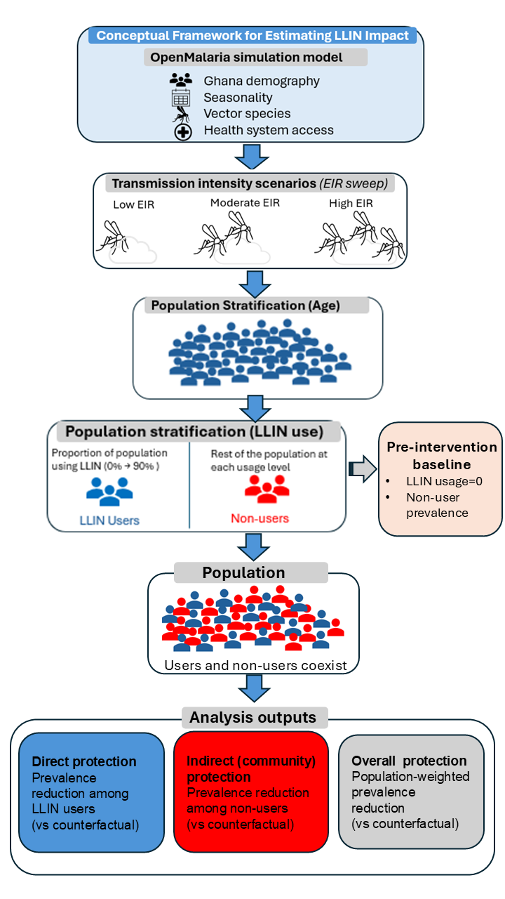
Figure 1: Conceptual framework for evaluating direct, indirect, and population-level effects of LLIN usage across transmission intensities. The OpenMalaria simulation model incorporates the demography, seasonality, vector species composition, and health system access of Nkwanta-South district in Ghana to simulate malaria transmission. Transmission intensity scenarios are defined through a range of entomological inoculation rates (EIRs) categorized into low, moderate, and high transmission intensities. For each transmission intensity, LLIN usage scenarios vary the proportion of the population using LLINs, generating distinct user and non-user groups. Individuals are stratified across age groups (0-5, 0-10 and 0–100 years), with users and non-users coexisting within the same simulated population. Outcomes include (i) direct protection, defined as the prevalence reduction among LLIN users relative to a counterfactual baseline (LLIN usage = 0); (ii) indirect protection, defined as prevalence reduction among non-users relative to the same baseline; and (iii) overall protection, defined as population-weighted prevalence reduction, relative to the baseline.

Results
The impact of LLINs on malaria prevalence among LLIN users, non-users and overall population did not change over time declined with usage but increased with transmission intensity
For a population of 10,000 individuals in a moderate transmission setting (EIR from 8 to 32, ${PfPR}_{0-100}$ between 0.12 and 0.34), we simulated LLINs being used by 60% of the population from the year 2023 and show in Figure 2A that all-age prevalence among LLIN users, non-users and the overall population drop from 40% to 19%, 27% and 22% respectively, by 2024. Here, all the three population groups experience a decline in malaria prevalence due to the use of LLINs in the population, with net users experiencing the lowest prevalence across the years compared to non-users and the overall population (Figure 2A). We did not observe a change in prevalence levels of the population groups over time, as prevalence levels were consistent within distribution cycles. The model was also used to project how malaria prevalence may differ among population groups for different levels of LLIN use (Figure 2B) and malaria endemicity (Figure 2C), using the average impact of LLINs within one LLIN distribution cycle (2026-2028). Malaria prevalence for all population groups declined as LLIN usage increased. At 60% usage, prevalence declined from 48% to 18%, 20% and 24% among LLIN users, the overall population and non-users respectively (Figure 2B). The prevalence predicted by the model increased for all population groups with increasing entomological inoculation rate (EIR, the mean number of infectious mosquito bites received per person per year), net users had the lowest prevalence across transmission intensities (Figure 2C).

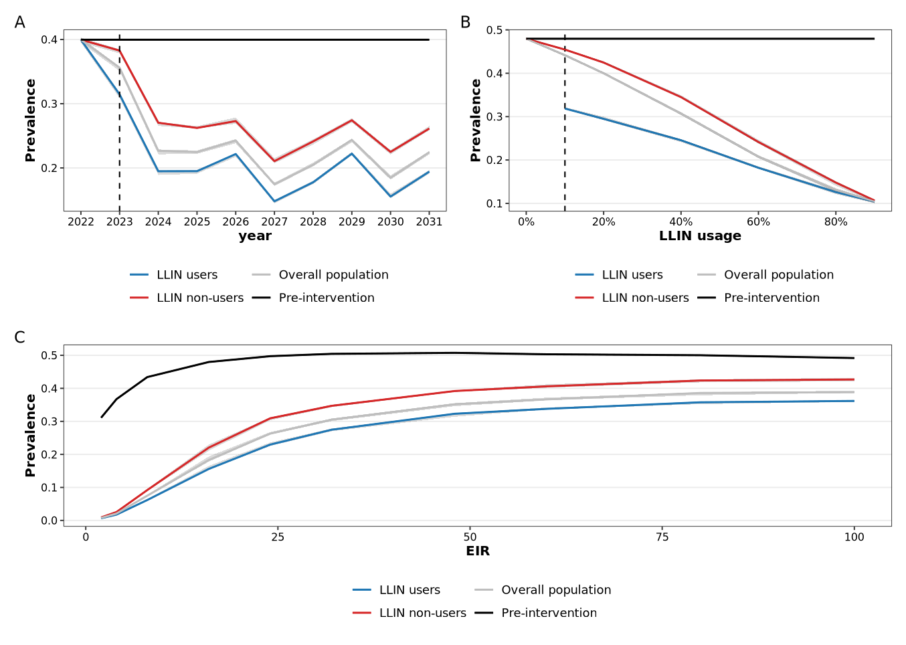
Figure 2: Impact of LLINs on malaria prevalence among LLIN users, non-users and the overall population declined with time and usage but increased with transmission intensity. (A) All-age prevalence levels over 10 years of simulation time, across moderate transmission (EIR between 8–32) and 60% LLIN use (Dashed line indicates the start of LLIN deployment. LLINs were deployed in 2023, 2026 and 2029, assuming a three-year distribution cycle). (B) All-age prevalence levels averaged over three years (one LLIN distribution cycle: 2026 – 2028) across moderate transmission (EIR between 8–32. Dashed line indicates lowest LLIN usage (10%)). (C) All-age prevalence levels averaged over three years (one LLIN distribution cycle: 2026 – 2028), at a usage level of 60%. We show the mean and interquartile range for 10 seeds for each EIR level (EIR levels from 2 to 100) for prevalence.
Protection offered by LLINs for all population groups increased with increasing usage and decreased with increasing transmission intensity
Direct and indirect protection of LLINs were quantified as reductions in prevalence among the population groups, relative to the no-LLIN baseline. Across all transmission settings, increasing LLIN usage from 40% to 80% led to consistent improvements in prevalence reduction for all population groups (users, non-users, and overall population), although the magnitude of these gains varied by transmission intensity. In low transmission settings (EIR < 8, ${ PfPR}_{0-100}$ [0.03-0.05]), LLINs achieved very high prevalence reduction across all groups, even at moderate coverage levels. At 40% usage, prevalence reduction was already high, reaching 89% (interquartile range: [89.6–90.1]) among users, 85% (interquartile range: [84.9–85.5]) in the overall population, and 82% (interquartile range: [81.9–82.7]) among non-users. Increasing coverage to 60% and 80% resulted in only minimal additional gains, with all groups approaching 94–98% reduction. Importantly, the difference between users and non-users was minimal across all coverage levels, indicating strong indirect protection even at relatively low coverage of 40% (Figure 3).
In moderate transmission settings (EIR between 8 and 32, ${ PfPR}_{0-100}$ [0.19-0.34]), LLINs produced substantial reductions, with clearer separation between protection types. At 40% usage, prevalence reduction was 48.9% (interquartile range: [ 48.5–49.3]) among users, compared to 36% (interquartile range: [35.6–36.2]) in the overall population and 27.9% (interquartile range: [27.5–28.1]) among non-users, indicating a strong gradient between direct and indirect protection. As coverage increased to 60% and 80%, all groups experienced notable improvements. At 80% usage, prevalence reduction reached 73.6% (interquartile range: [73.1–74.7]) among users, 72.6% (interquartile range: [72.0–73.7]) in the overall population, and 69.1% (interquartile range: [ 68.7–70.6]) among non-users. The gap between users and non-users narrows substantially at higher coverage, reflecting increasing indirect protection (Figure 3).
In high transmission settings (EIR between 32 and 100, ${ PfPR}_{0-100}$ [0.38-0.46]), LLINs yielded more modest reductions in prevalence, and the distinction between protection types remained pronounced. At 40% usage, prevalence reduction was limited, with 26.2% (interquartile range: [25.9–26.8]) among users, 16% (interquartile range: [15.8–16.3]) in the overall population, and 9.5% (interquartile range: [9.3–9.9]) among non-users. Increasing coverage to 60% and 80% led to incremental improvements, reaching 37.3% (interquartile range: [36.7–37.6]) among users, 35.3% (interquartile range: [34.9–35.8]) in the overall population, and 29.4% (interquartile range: [28.9–30.0]) among non-users at 80% usage. Despite these gains, a clear gradient persists between users and non-users across all coverage levels, indicating that indirect protection is weaker and accumulates more slowly in high transmission settings (Figure 3). Comparing the protection offered by LLINs across transmission settings revealed that the magnitude of impact declines with increasing transmission intensity. LLIN effectiveness is highest in low transmission settings and progressively reduced in moderate and high transmission settings. Indirect protection is strongest in low transmission settings. The rapid convergence of users, non-users, and population-level outcomes indicates that indirect effects are highly efficient at low transmission, even at moderate usage. Dependence on usage increases with transmission intensity. While low transmission settings achieve near-maximal impact at relatively low usage, moderate and high transmission settings require substantially higher usage to achieve meaningful indirect effects, and even then, full convergence is not observed (Figure 3).

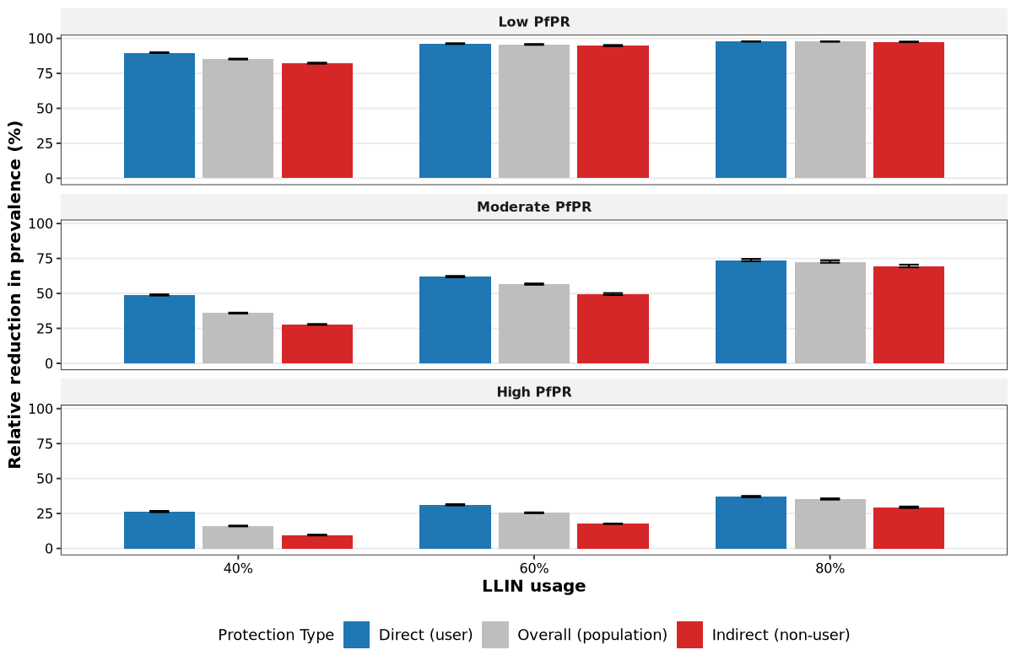
Figure 3: Relative reduction in prevalence (protection) among users, non-users and the overall population increase with increasing usage and decreases with transmission intensities. The reduction in prevalence is calculated from a counterfactual scenario, where nobody in the population is given a net. Direct(user), Indirect(non-user) and overall (population-level) protections are represented here for 40%, 60% and 80% of the population using nets. The grouped bar plots at each usage level show results for a different type of protection. The protection for users is shown in blue, non-users in red and the overall population in grey. Mean and interquartile range are shown for 10 seeds for each EIR level (EIR levels from 2 to 100) for relative prevalence reduction
Usage thresholds for incremental and predefined benefits increase with increasing transmission intensity
The incremental benefit of increasing LLIN usage varies substantially with transmission intensity. At low transmission intensity, increasing LLIN usage from 10% to 20% (corresponding to an additional 1,000 individuals protected in a population of 10,000) resulted in a 1.2 percentage-point increase in prevalence reduction among users, compared to a 2.4 percentage-point increase among non-users. Most of the benefit is achieved early. Beyond 60%, adding more nets yields very little. In moderate transmission settings we observed a peak at intermediate usage (40% to 60%), indicating that there is an optimal usage window where incremental gains are highest. In contrast, no optimal usage range is observed in high-transmission settings as gains continue to increase with usage. LLIN usage thresholds were estimated separately by linearly interpolating the LLIN usage required to achieve 25% and 50% prevalence reduction among non-users. The LLIN usage required to achieve comparable levels of indirect protection among non-users varied substantially by transmission intensity (Figure 4). In low transmission settings, both 25% and 50% reductions in non-user prevalence were achieved at relatively low usage levels (12% and 23% respectively), indicating that community protection emerges rapidly. In moderate transmission settings, higher usage levels were required (36% and 61% respectively), with thresholds typically occurring in the mid-usage range, reflecting a greater dependence on widespread LLIN use to generate indirect effects. In high transmission settings, only 25% reduction in non-user prevalence could be achieved at a substantially higher usage (72%), highlighting the difficulty of generating community protection in high transmission settings. These findings demonstrate that the usage thresholds required for meaningful indirect protection are strongly transmission dependent.

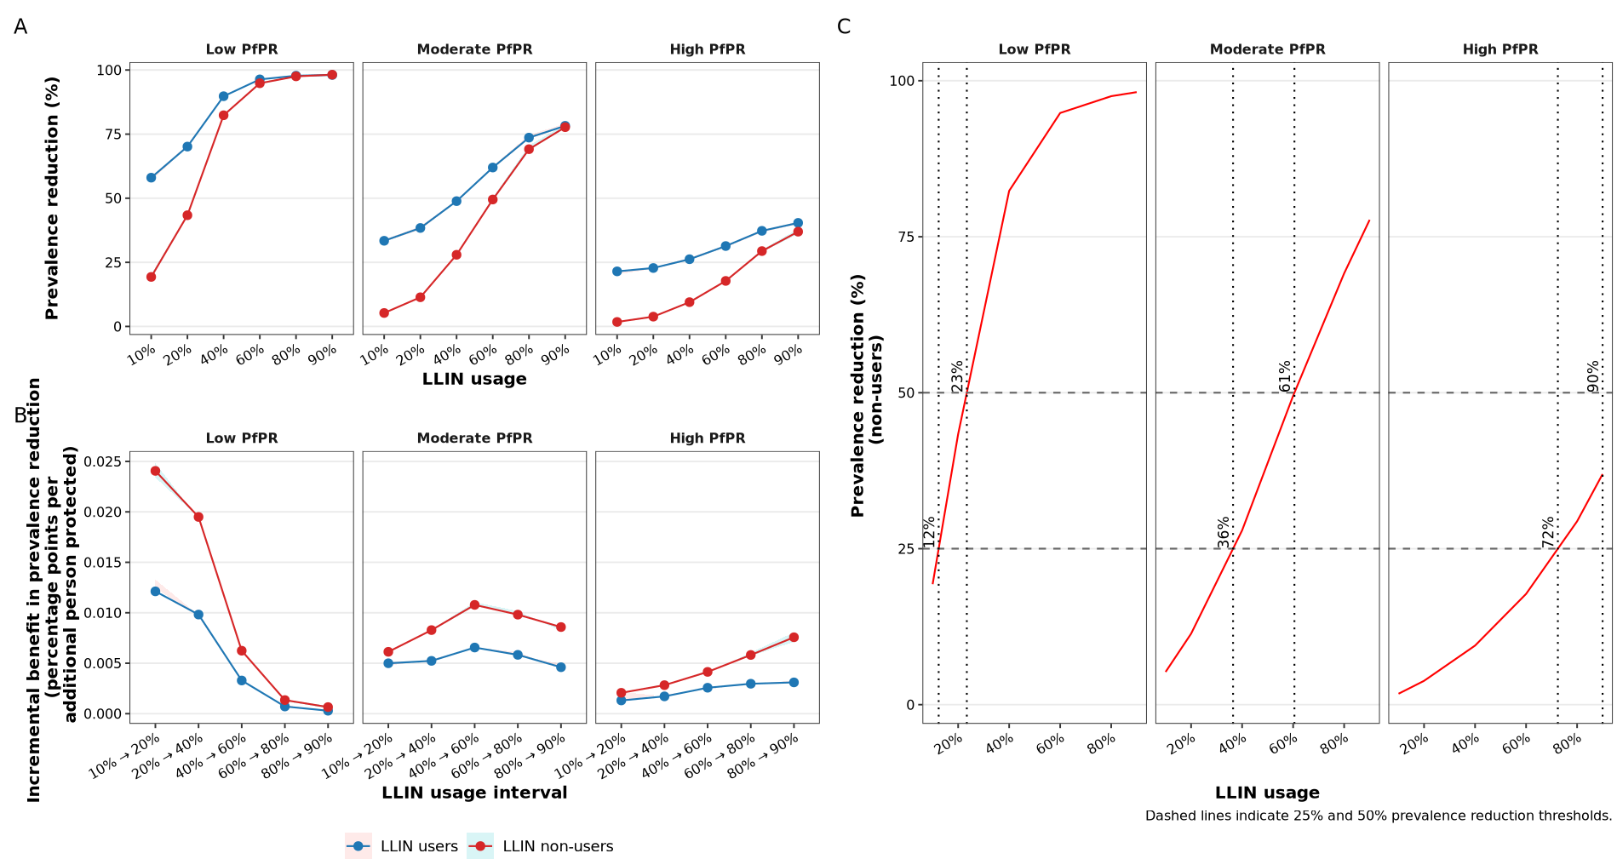
Figure 4: Incremental benefits per additional person protected. (A) is the relative prevalence reduction for both users and non-users, averaged over three years (2026-2028) to represent one LLIN distribution cycle. (B) shows the incremental benefit in prevalence reduction per additional person protected. (C) is the relationship between LLIN usage and prevalence reduction among non-users is shown for transmission intensity levels. Horizontal dashed lines indicate 25% and 50% prevalence reduction thresholds, and vertical dotted lines indicate the LLIN usage required to achieve these thresholds. Required LLIN usage increases monotonically with transmission intensity, reaching near-universal coverage levels at high EIR levels. Red represents non-users and blue represents users.

Discussion
- What we did
Long-lasting insecticidal nets offer protection to both users and non-users in the population, but how this protection varies across transmission intensity and coverage remains incompletely evaluated as empirical studies are usually context specific. In this modelling study, we used an agent-based model of malaria transmission [26] to quantify how the protection offered by long-lasting insecticidal nets (LLINs) varies across transmission intensities and usage, and to find the optimal usage thresholds at which incremental gains are highest. This results in important implications for intervention prioritization.
- Findings and Alignment with previous studies
Our findings reinforce existing evidence that LLIN offer protection for both users and individuals in the community who do not use nets. Hawley et al. found that households without treated nets benefited when located near households with treated nets in western Kenya, supporting the existence of a community effect [9]. More recently, Unwin and colleagues used a transmission model to quantify the direct and indirect protection from insecticide-treated nets and showed that both users and non-users can benefit from community protection [15]. Simulations indicated that the magnitude of community protection varies substantially across transmission settings. This dependence on transmission intensity we observed is also consistent with previous literature. In low transmission settings, indirect protection increases rapidly with coverage and approaches the level of direct protection at moderate coverage levels, indicating strong community-wide effects. Griffin et al. similarly showed that high LLIN coverage could reduce prevalence to very low levels in low-transmission settings, while substantially higher transmission settings were less responsive to LLIN scale-up alone [40]. In contrast, in high transmission settings, indirect protection remains limited even at high coverage, highlighting the persistence of transmission despite widespread LLIN use. This is consistent with programmatic evidence from Uganda showing that universal LLIN distribution produced only modest improvements in some higher-burden settings, and that additional IRS was needed to achieve larger gains where transmission remained intense [41]. Analysis of incremental benefit reveals that the incremental gains associated with increasing LLIN coverage are not constant. In low transmission settings, incremental benefits are highest at low coverage levels and decline sharply as coverage increases, indicating strong diminishing returns and the presence of a coverage ceiling. In moderate transmission settings, incremental benefits peak at intermediate coverage levels, suggesting an optimal range where additional coverage yields the highest benefit. In high transmission settings, however, incremental benefits continue to grow with coverage, with no clear evidence of saturation within the range examined. While WHO recommends universal coverage that covers everyone one at risk of malaria [19], and some prior work highlighting the importance of high coverage [15,42], our results suggest that the efficiency of additional usage is context-dependent, and that increasing coverage beyond certain levels may yield limited additional benefit in some transmission settings. The results here therefore support the importance of high coverage for high transmission settings but also support more broadly the finding that moderate coverage levels are enough to produce equitable community effects of insecticide treated nets [16], as seen here in low and moderate transmission settings. These patterns translate into distinct usage thresholds required to achieve comparable levels of protection among non-users across transmission settings. In low transmission settings, relatively modest usage levels are sufficient to achieve substantial reductions in prevalence, whereas in high transmission settings, much higher usage is required to achieve comparable levels of indirect protection. Earlier modelling by Killeen et al. did argue for rational all-age coverage targets and highlighted the importance of community-level protection, which is broadly consistent with our threshold-oriented framing, but it did not estimate the same incremental-benefit metric used here [16].
- Policy implications
These findings have direct implications for malaria control strategies, particularly in the context of constrained resources. In low transmission settings, where indirect protection is strong and marginal gains decline rapidly, achieving moderate usage may be sufficient to generate substantial community-wide benefits. Beyond this level, additional increases in usage yield limited incremental benefit. In such settings, resources may be more effectively allocated in alternative ways such as maintaining usage by improving LLIN access between mass LLIN distribution campaigns through continuous distribution channels to bridge usage gaps [19], organizing social and behavioural change campaigns or investing in complementary interventions. In moderate transmission settings, our results indicate the existence of an optimal usage range, within which incremental benefits are maximized. Targeting this range may provide the highest return on investment. In high transmission settings, where indirect effects remain limited and incremental benefits continue to grow with usage, maximizing LLIN usage remains essential. These findings support recommendations for high coverage in high-burden settings but also highlight the importance of context-specific strategies rather than uniform coverage targets [19]. Since community protection depends strongly on the killing effect of nets, the distribution of net products that kill mosquitoes most effectively should be prioritized by policy makers to ensure these usage thresholds still confer substantial protection to non-users.
- limitations and strengths
A key strength of this study is the integrated analysis of direct, indirect, and incremental effects of LLIN coverage within a unified modelling framework, allowing for a comprehensive assessment of both total and incremental impact. By explicitly quantifying usage thresholds, we provide outputs that are directly relevant to policy and decision-making. However, several limitations should be noted. The study relies on a model of malaria transmission, which is a simplification of reality, and may not fully capture all sources of heterogeneity present in real-world contexts, including variations in human behaviour, spatial heterogeneity, and intervention adherence. We could not account for spatial heterogeneity in the model and hence assume that non-users are in close proximity enough to LLIN users to benefit from reduced transmission. The analysis focuses on prevalence reduction and does not directly incorporate other outcomes such as incidence, severe disease, or cost-effectiveness, which are also critical for decision-making. The effect of the spread of pyrethroid resistance across sub-Saharan Africa [43] was not considered in this study which could alter the LLIN effects seen here. Previous studies suggest that the higher infection rates observed among non-users compared to users in recent data may reflect diminished community protection, potentially driven by pyrethroid resistance [44]. However, a modelling study by Unwin et al. found very little difference between users and non-users in the presence of insecticide resistance, but also caution that their estimates may be highly variable [15]. Also, it has been demonstrated that the benefits derived from LLINs deployed against vector populations that are already pyrethroid-resistant depend on killing more mosquitoes than on protecting more humans [42]. This means that in areas with resistant mosquitoes to pyrethroids, switching to next-generation nets can still preserve community protection even in resistant settings at the usage thresholds identified here.

Conclusion

Overall, our results support a context-specific interpretation of LLIN scale-up. Prior literature clearly supports the existence of direct and community protection from insecticide-treated nets and shows that intervention impact depends on transmission intensity. Building on that foundation, our study suggests that the epidemiological return to each additional increase in LLIN coverage is itself transmission-dependent, and that this can be translated into practical coverage thresholds for decision-making.

References
1. Bhatt S, Weiss DJ, Cameron E, Bisanzio D, Mappin B, Dalrymple U, et al. The effect of malaria control on Plasmodium falciparum in Africa between 2000 and 2015. Nature. 2015;526:207–11. https://doi.org/10.1038/nature15535
2. Raghavendra K, Barik TK, Reddy BPN, Sharma P, Dash AP. Malaria vector control: from past to future. Parasitol Res. 2011;108:757–79. https://doi.org/10.1007/s00436-010-2232-0
3. Briët OJT, Penny MA, Hardy D, Awolola TS, Van Bortel W, Corbel V, et al. Effects of pyrethroid resistance on the cost effectiveness of a mass distribution of long-lasting insecticidal nets: a modelling study. Malar J. 2013;12:77. https://doi.org/10.1186/1475-2875-12-77
4. Okumu F. The fabric of life: what if mosquito nets were durable and widely available but insecticide-free? Malar J. 2020;19:260. https://doi.org/10.1186/s12936-020-03321-6
5. Killeen GF, Okumu FO, N’Guessan R, Coosemans M, Adeogun A, Awolola S, et al. The importance of considering community-level effects when selecting insecticidal malaria vector products. Parasit Vectors. 2011;4:160. https://doi.org/10.1186/1756-3305-4-160
6. Lukole EA, Cook J, Mosha JF, Matowo NS, Kulkarni MA, Mallya E, et al. Community benefits of mass distribution of three types of dual-active-ingredient long-lasting insecticidal nets against malaria prevalence in Tanzania: evidence from a 3-year cluster-randomized controlled trial. BMC Public Health. 2025;25:346. https://doi.org/10.1186/s12889-025-21586-x
7. Unwin HJT, Sherrard-Smith E, Churcher TS, Ghani AC. Quantifying the direct and indirect protection provided by insecticide treated bed nets against malaria. Nat Commun. 2023;14:676. https://doi.org/10.1038/s41467-023-36356-9
8. Ko YK, Kagaya W, Chan CW, Kanamori M, Mbugua SM, Rotich AK, et al. Unraveling the “community effects” of interventions against malaria endemicity: a systematic scoping review. BMJ Public Health. 2024;2:e001557. https://doi.org/10.1136/bmjph-2024-001557
9. Hawley WA, Phillips-Howard PA, ter Kuile FO, Terlouw DJ, Vulule JM, Ombok M, et al. Community-wide effects of permethrin-treated bed nets on child mortality and malaria morbidity in western Kenya. Am J Trop Med Hyg. 2003;68:121–7.
10. Lukole EA, Cook J, Mosha JF, Matowo NS, Kulkarni MA, Mallya E, et al. Community benefits of mass distribution of three types of dual-active-ingredient long-lasting insecticidal nets against malaria prevalence in Tanzania: evidence from a 3-year cluster-randomized controlled trial. BMC Public Health. 2025;25:346. https://doi.org/10.1186/s12889-025-21586-x
11. ter Kuile FO, Terlouw DJ, Kariuki SK, Phillips-Howard PA, Mirel LB, Hawley WA, et al. Impact of permethrin-treated bed nets on malaria, anemia, and growth in infants in an area of intense perennial malaria transmission in western Kenya. Am J Trop Med Hyg. 2003;68:68–77.
12. Benjamin-Chung J, Li H, Nguyen A, Barratt Heitmann G, Bennett A, Ntuku H, et al. Extension of efficacy range for targeted malaria-elimination interventions due to spillover effects. Nat Med. 2024;30:2813–20. https://doi.org/10.1038/s41591-024-03134-z
13. Killeen GF, Smith TA, Ferguson HM, Mshinda H, Abdulla S, Lengeler C, et al. Preventing childhood malaria in Africa by protecting adults from mosquitoes with insecticide-treated nets. PLoS Med. 2007;4:e229. https://doi.org/10.1371/journal.pmed.0040229
14. Killeen GF, Okumu FO, N’Guessan R, Coosemans M, Adeogun A, Awolola S, et al. The importance of considering community-level effects when selecting insecticidal malaria vector products. Parasit Vectors. 2011;4:160. https://doi.org/10.1186/1756-3305-4-160
15. Unwin HJT, Sherrard-Smith E, Churcher TS, Ghani AC. Quantifying the direct and indirect protection provided by insecticide treated bed nets against malaria. Nat Commun. 2023;14:676. https://doi.org/10.1038/s41467-023-36356-9
16. Killeen GF, Smith TA, Ferguson HM, Mshinda H, Abdulla S, Lengeler C, et al. Preventing childhood malaria in Africa by protecting adults from mosquitoes with insecticide-treated nets. PLoS Med. 2007;4:e229. https://doi.org/10.1371/journal.pmed.0040229
17. Benjamin-Chung J, Li H, Nguyen A, Barratt Heitmann G, Bennett A, Ntuku H, et al. Extension of efficacy range for targeted malaria-elimination interventions due to spillover effects. Nat Med. 2024;30:2813–20. https://doi.org/10.1038/s41591-024-03134-z
18. Janko MM, Churcher TS, Emch ME, Meshnick SR. Strengthening long-lasting insecticidal nets effectiveness monitoring using retrospective analysis of cross-sectional, population-based surveys across sub-Saharan Africa. Sci Rep. 2018;8:17110. https://doi.org/10.1038/s41598-018-35353-z
19. WHO recommendations for achieving universal coverage with long-lasting insecticidal nets in malaria control | WHO | Regional Office for Africa [Internet]. 2026 [cited 2026 Mar 26]. https://www.afro.who.int/publications/who-recommendations-achieving-universal-coverage-long-lasting-insecticidal-nets. Accessed 26 Mar 2026
20. Smith T, Ross A, Maire N, Chitnis N, Studer A, Hardy D, et al. Ensemble Modeling of the Likely Public Health Impact of a Pre-Erythrocytic Malaria Vaccine. PLOS Med. 2012;9:e1001157. https://doi.org/10.1371/journal.pmed.1001157
21. Smith T, Killeen GF, Maire N, Ross A, Molineaux L, Tediosi F, et al. MATHEMATICAL MODELING OF THE IMPACT OF MALARIA VACCINES ON THE CLINICAL EPIDEMIOLOGY AND NATURAL HISTORY OF PLASMODIUM FALCIPARUM MALARIA: OVERVIEW. Am J Trop Med Hyg. 2006;75:1–10. https://doi.org/10.4269/ajtmh.2006.75.2_suppl.0750001
22. Maire N, Smith T, Ross A, Owusu-Agyei S, Dietz K, Molineaux L. A model for natural immunity to asexual blood stages of Plasmodium falciparum malaria in endemic areas. Am J Trop Med Hyg. 2006;75:19–31. https://doi.org/10.4269/ajtmh.2006.75.19
23. Chitnis N, Smith T, Steketee R. A mathematical model for the dynamics of malaria in mosquitoes feeding on a heterogeneous host population. J Biol Dyn. 2008;2:259–85. https://doi.org/10.1080/17513750701769857
24. Chitnis N, Hardy D, Smith T. A Periodically-Forced Mathematical Model for the Seasonal Dynamics of Malaria in Mosquitoes. Bull Math Biol. 2012;74:1098–124. https://doi.org/10.1007/s11538-011-9710-0
25. Smith T, Killeen GF, Maire N, Ross A, Molineaux L, Tediosi F, et al. Mathematical modeling of the impact of malaria vaccines on the clinical epidemiology and natural history of Plasmodium falciparum malaria: Overview. Am J Trop Med Hyg. 2006;75:1–10. https://doi.org/10.4269/ajtmh.2006.75.2_suppl.0750001
26. OpenMalaria Online wiki [Internet]. GitHub. [cited 2025 Apr 23]. https://github.com/SwissTPH/openmalaria/wiki/Home. Accessed 23 Apr 2025
27. Chitnis N, Smith T, Steketee R. A mathematical model for the dynamics of malaria in mosquitoes feeding on a heterogeneous host population. J Biol Dyn. 2008;2:259–85. https://doi.org/10.1080/17513750701769857
28. Reiker T, Chitnis N, Smith T. Modelling reactive case detection strategies for interrupting transmission of Plasmodium falciparum malaria. Malar J. 2019;18:259. https://doi.org/10.1186/s12936-019-2893-9
29. Smith T, Maire N, Ross A, Penny M, Chitnis N, Schapira A, et al. Towards a comprehensive simulation model of malaria epidemiology and control. Parasitology. 2008;135:1507–16. https://doi.org/10.1017/S0031182008000371
30. Swiss TPH. openMalariaUtilities [Internet]. [cited 2024 Jul 21]. https://github.com/SwissTPH/r-openMalariaUtilities. Accessed 21 Jul 2024
31. NMEP G. National Malaria Elimination Strategic Plan [Internet]. https://mesamalaria.org/resource-hub/national-malaria-elimination-strategic-plan-nmesp-of-ghana-2024-2028/
32. Galactionova K, Tediosi F, Savigny D de, Smith T, Tanner M. Effective Coverage and Systems Effectiveness for Malaria Case Management in Sub-Saharan African Countries. PLOS ONE. 2015;10:e0127818. https://doi.org/10.1371/journal.pone.0127818
33. Beier JC, Killeen GF, Githure JI. Short report: entomologic inoculation rates and Plasmodium falciparum malaria prevalence in Africa. Am J Trop Med Hyg. 1999;61:109–13. https://doi.org/10.4269/ajtmh.1999.61.109
34. Hakizimana E, Karema C, Munyakanage D, Githure J, Mazarati JB, Tongren JE, et al. Spatio-temporal distribution of mosquitoes and risk of malaria infection in Rwanda. Acta Trop. 2018;182:149–57. https://doi.org/10.1016/j.actatropica.2018.02.012
35. WHO guidelines for malaria [Internet]. [cited 2026 Mar 27]. https://www.who.int/publications/i/item/guidelines-for-malaria. Accessed 27 Mar 2026
36. Golumbeanu M, Briët O, Champagne C, Lemant J, Winkel M, Zogo B, et al. AnophelesModel: An R package to interface mosquito bionomics, human exposure and intervention effects with models of malaria intervention impact. PLOS Comput Biol. 2024;20:e1011609. https://doi.org/10.1371/journal.pcbi.1011609
37. Chitnis N, Schapira A, Smith T, Steketee R. Comparing the effectiveness of malaria vector-control interventions through a mathematical model. Am J Trop Med Hyg. 2010;83:230–40. https://doi.org/10.4269/ajtmh.2010.09-0179
38. OpenMalaria wiki [Internet]. GitHub. [cited 2024 Mar 16]. https://github.com/SwissTPH/openmalaria/wiki/Home. Accessed 16 Mar 2024
39. Moody A. Rapid Diagnostic Tests for Malaria Parasites. Clin Microbiol Rev. 2002;15:66–78. https://doi.org/10.1128/CMR.15.1.66-78.2002
40. Griffin JT, Hollingsworth TD, Okell LC, Churcher TS, White M, Hinsley W, et al. Reducing Plasmodium falciparum Malaria Transmission in Africa: A Model-Based Evaluation of Intervention Strategies. PLOS Med. 2010;7:e1000324. https://doi.org/10.1371/journal.pmed.1000324
41. Katureebe A, Zinszer K, Arinaitwe E, Rek J, Kakande E, Charland K, et al. Measures of Malaria Burden after Long-Lasting Insecticidal Net Distribution and Indoor Residual Spraying at Three Sites in Uganda: A Prospective Observational Study. Garner P, editor. PLOS Med. 2016;13:e1002167. https://doi.org/10.1371/journal.pmed.1002167
42. Killeen GF. Control of malaria vectors and management of insecticide resistance through universal coverage with next-generation insecticide-treated nets. The Lancet. 2020;395:1394–400. https://doi.org/10.1016/S0140-6736(20)30745-5
43. Hancock PA, Hendriks CJM, Tangena J-A, Gibson H, Hemingway J, Coleman M, et al. Mapping trends in insecticide resistance phenotypes in African malaria vectors. PLOS Biol. 2020;18:e3000633. https://doi.org/10.1371/journal.pbio.3000633
44. Kleinschmidt I, Bradley J, Knox TB, Mnzava AP, Kafy HT, Mbogo C, et al. Implications of insecticide resistance for malaria vector control with long-lasting insecticidal nets: a WHO-coordinated, prospective, international, observational cohort study. Lancet Infect Dis. 2018;18:640–9. https://doi.org/10.1016/S1473-3099(18)30172-5

